1. Create codecommit repository

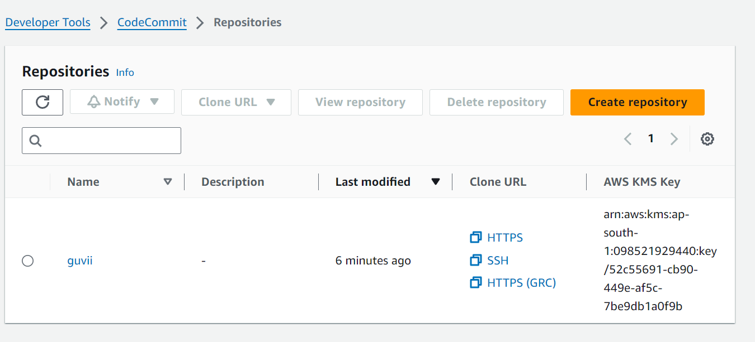

1. Create a IAM user to access the repository

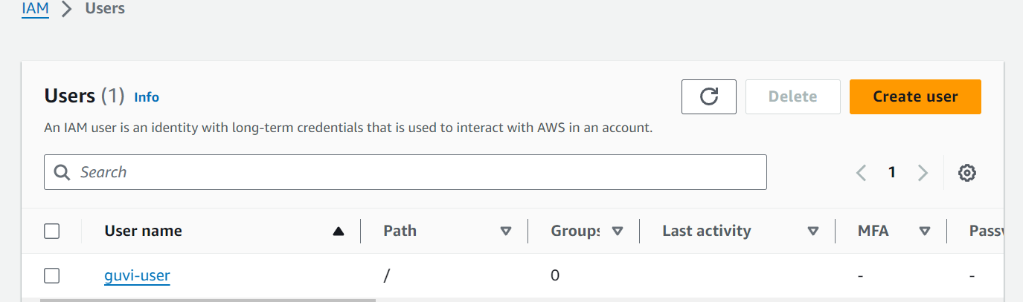

1. Deploy simple index.html in nginx

